As the Garden Grows
A Publication of the Gonzales Master Gardeners
Gonzales, Texas December 2018 Volume 8, Issue 11
Volunteer of the Year Awards for 2018
(Submitted by Fran Saliger)
Each year at our December Winter Social, a Volunteer or Volunteers of the Year is announced. This year’s very deserving recipients were Dwaine Siptak and Gail Johnson.
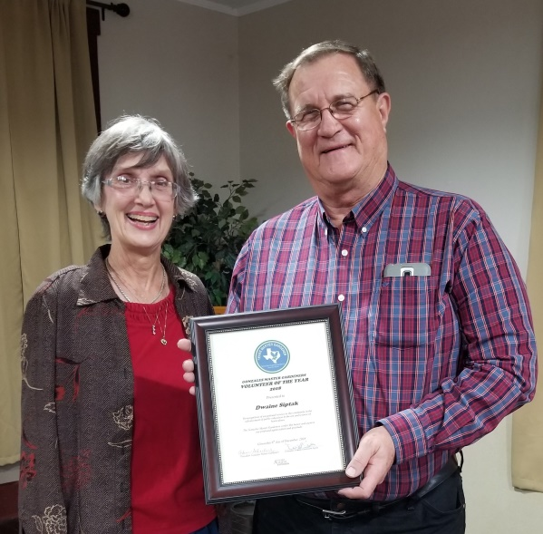
Dwaine Siptak graduated in May 2018 with Class #8. I honestly cannot remember a time when Dwaine was not there to help out wherever the need arose. He jumped right in at the beginning of his class training in September 2017 and never stopped volunteering. As a retired Safety officer at BYK (aka Southern Clay), he has kept the board up to date on safety issues around the building. Thanks for taking care of all of us who work in and around the building and grounds. He is a delight to work with and we look forward to his continued efforts as a Gonzales Master Gardener Volunteer.

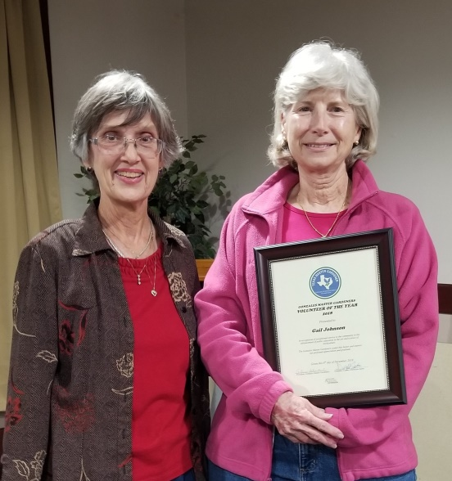
Gail Johnson, founding member of GMG, has never let us down. She was instrumental in putting GMG in the spotlight once again this year by leading and organizing the first Plant Health and Diagnostics Educator Specialist Training Class in Gonzales last February. She has given several Lunch and Learn Seminars, taught MG training classes and been there for much needed advice when asked. You can always count on Gail to be there when you need her.

Thanks to both of you for a job well done.

Everyone should know that without our volunteers our organization cannot function. Each of you is very special and every volunteer hour is greatly appreciated. It takes a great team of volunteers doing what you can, to make Gonzales Master Gardeners the best group in the State of Texas!
THANK YOU ALL VERY MUCH
Fran Saliger, Volunteer Coordinator.
New Board of Directors Takes the Reign for 2019-2021
Every two years, a new Board of Directors is voted upon by the membership to lead the Gonzales Master Gardeners. This year’s directors are:
Arline Schacherl, President
Jacky DuCote, Vice President (Volunteer Coordinator)
Robbie Cole, Secretary
Nick Wentworth, Treasurer
David DeMent, Past President
The board meets once a month on the last Thursday of the month (subject to change as necessary). If you have something to discuss with the board, you are welcome to come as a guest and state your concerns or suggestions.

First Grade Children’s Garden Program
The Spring Session for the Children’s Garden with the first graders at GISD will begin in January. Stay tuned for emails from Arline Schacherl, program leader, for more information. The first class room session is planned for January 10, 2019. The remaining times are scheduled as follows:
1/24/19 (alt 1/25/19) – Classroom
2/21/19 (alt 2/22/19) – Plant at Children’s Garden
3/21/19 (alt 3/22/19) – Visit and harvest any produce that is ready
4/25/19 (alt 4/26/19) – Final visit and harvest

Second Grade Program
The next session for the GISD second grade students is scheduled for January 31, 2019. David DeMent is planning a program about where paper products come from. The students will be making paper mache Valentine cards. If you have a blender that we can use for this program, please let Fran Saliger know ASAP. We will be scheduling a practice day for the paper mache process so stay tuned for upcoming information.

3rd Grade Black Walnut Tree Restoration Project
On November 28, the third grade students from GISD came to the PACE building to learn about restoration and conservation of the Black Walnut Trees in Gonzales County. With the leadership of Donna Bell, the program was informative and fun for the students.
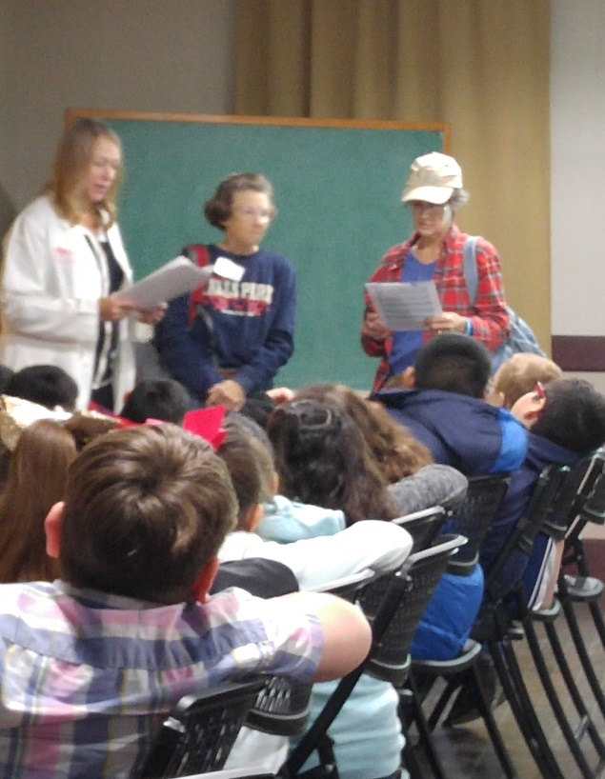
Each session included a skit presented by Master Gardeners Kristy Posey (student in class #9), Arline Schacherl, and Carolyn Parratt. Peter (Arline) and Susie (Carolyn) are trying to figure out how to “Save the Planet” when along comes Professor Smith (Kristy) to explain that black walnut trees were going extinct in Gonzales County. The walnut trees were cut down in the early 1900’s to make furniture for the community but never replenished. The professor explained how important it is to replace what we use. In the case of the walnut trees, planting new trees was the answer. Taking care of all our natural resources is so important and we must work to restore and replenish resources where we can.
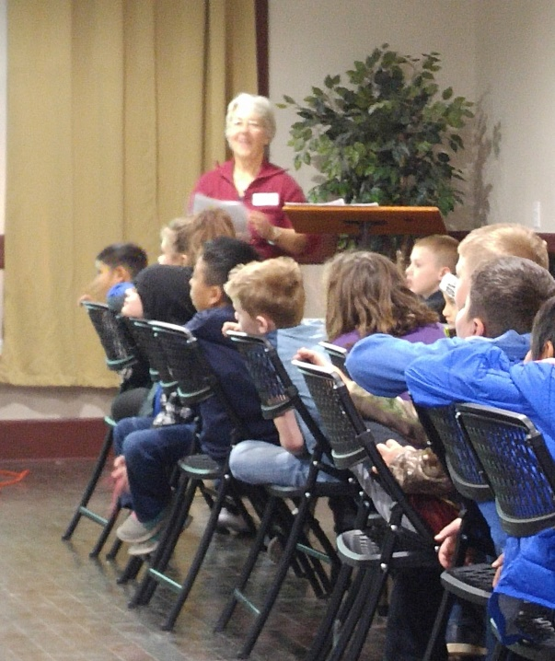
The 220 students then planted walnut seeds to be grown at the Gonzales Elementary Orchard which is located on the south end of the grounds at PACE. These trees that germinate and grow will be distributed to Gonzales County residents next fall (2019). Over the past few years, GMG have distributed many trees to Gonzales County residents in hopes of restoring the black walnut tree in the county. In the fall of 2018, thirty-two trees were given to the Gonzales Rotary Club in memory of the 32 men from Gonzales who went to help defend the Alamo. The trees, planted in the J.B.Wells Park near the bridge on Hwy.183, will serve as a reminder to the community of the sacrifice of our heroes and the necessity to protect our environment.
This is Donna’s last year to serve as leader of the 3rd grade program. She has done an outstanding job of leading the program for the past three years. Jan Fiebig has stepped up to be the leader for the 2019 school year. She will be looking for volunteers to help maintain the “Tree Orchard” for the next year. Thanks to both of you for volunteering.

  - Gonzales Master Gardeners
  - 9th Annual Spring Plant Sale

Save the Date

Saturday, March 16, 2019
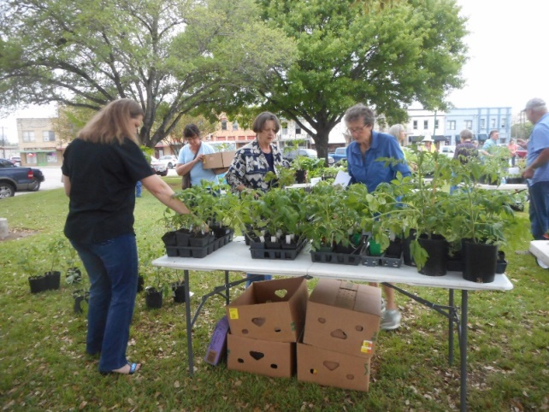
Winter is here, but it will soon be time to think about planting a vegetable garden and some spring blooming annuals. Now is a great time to get your flower/vegetable beds ready for planting. When Spring fever hits, Gonzales Master Gardeners will have your favorite plants ready for planting.
*****************************************************************
Grow Teams are already working on getting plants ready for the spring sale. Sandy Llewellyn has vegetable seeds ready for you to plant and grow for the sale. Now is the time to prepare and start growing vegetable plants. Pots and soil are available at the Greenhouse. Dee Sengelmann, Herb Grow Team leader, is ready to get the herbs growing. She is desperately seeking someone to help her with the grow team as she will be going on vacation the week of the sale. Shirley and Fran are looking for MG’s to help grow annuals and perennials in the Greenhouse.
A planning meeting will be held January 3, 2019 after the noon MG general Meeting. As you all know by now, the committee needs lots of volunteers for all the various aspects of organizing the plant sale.

Gonzales Master Gardener Annual Dues

Gonzales Master Gardener member dues for 2019 are now DUE (deadline is December 31, 2018). If you are one of those that have not paid your 2019 annual dues, please send a $20 check, made out to GMG, to Nick Wentworth, 670 CR 447, Waelder TX 78959.

If you don’t wish to continue your membership with Gonzales Master Gardener’s, please inform Nick.

January Noon MG General Meeting

The next general meeting for GMG will be Thursday, January 3, 2019. Lunch will be provided by Shirley Frazier and Joyce Soefji. Bring a door prize and find out what’s happening for the 2019 year.

Are You Smarter Than a Second Grader?
In last month’s newsletter we were all given a chance to test our knowledge about insects! How many correct answers did you get? The answers are given here.

Vocabulary Meaning
Metamorphosis to change form
Pupae resting stage of an insect
Instars the stage between molts
Larvae the stage of an insect
Chrysalis houses an adult butterfly before birth
Naiad an aquatic larvae
Nymph the second stage of an insect in an incomplete lifecycle
Adult the reproductive stage of an insect
Molt shedding skin to grow
Incomplete three stage lifecycle
Complete four stage lifecycle
Exoskeleton hard outside skeleton

Ture or False
1. True A nymph does not have wings
2. False A pupa must eat a lot so that it can grow quickly.
3. True When a larva molts, it sheds its outer layer of skin.
4. True Most adult insects have six legs, three body parts, and antennae.
5. False Incomplete metamorphosis involves a drastic change in body form.

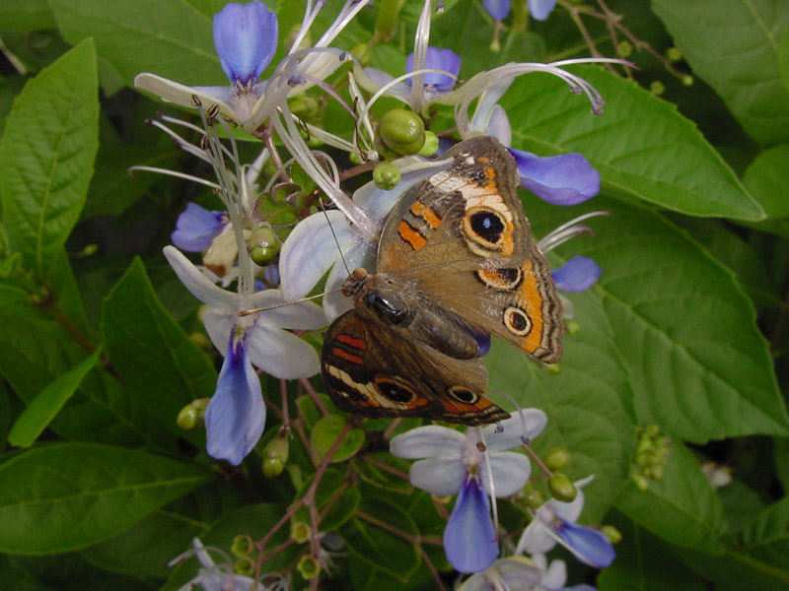

DATES TO REMEMBER: (Check elsewhere in newsletter for details)
Unless otherwise noted, all meetings/classes are at
623 N. Fair Street (Plantatarium: A Center for Exploration-aka PACE)

 | 17 | 18 | 19 | 20 | 21 | 22
23 | 24 | 25 | 26 | 27 | 28 | 29
30 | 31  Volunteer hours due | JANUARY 1 | 2 | 3  Noon MG lunch meeting  SPS Meeting 1:30 pm | 4 | 5
6 | 7 | 8  MG Class  How to Plant Trees- Mark Kroeze | 9 | 10  1st grade Class Session | 11 | 12
13 | 14 | 15 | 16 | 17 | 18 | 19
20 | 21 | 22  MG Class Vegetable Gardening- Larry Stein | 23 | 24  1st grade Class Session | 25 | 26
27 | 28 | 29  MG Class Southern Gardens and Landscaping-William C. Welch | 30 | 31  2nd Grade Program  Volunteer hours due | February 1 | 2
3 | 4 | 5 | 6 | 7  Noon MG lunch meeting | 8 | 9

Editors: Texas A&M AgriLife Extension Office
Fran Saliger 1709 E. Sarah DeWitt Drive
fsaliger@gvec.net Gonzales, TX 78629
Charlotte Knox Phone: 830-672-8531
lotteknox@aol.com Fax: 830-672-8532
Carolyn Parratt: Photographer E-mail: gonzales@ag.tamu.edu

Web pages: http://gonzalesmastergardeners.org

http://gonzales.agrilife.org

Extension programs serve people of all ages regardless of socioeconomic level, race, color, sex, religion, disability, or national origin. The Texas A&M University System, U.S. Department of Agriculture, and the County Commissioners Courts of Texas cooperating. Individuals with disabilities who require an auxiliary aid, service or accommodations in order to participate in this meeting are encouraged to contact the County Extension Office at 830-672-8531 to determine how reasonable accommodations can be made. The information given herein is for educational purposes only. Reference to commercial products or trade names is made with the understanding that no discrimination is intended and no endorsement by the Texas A & M AgriLife Extension

