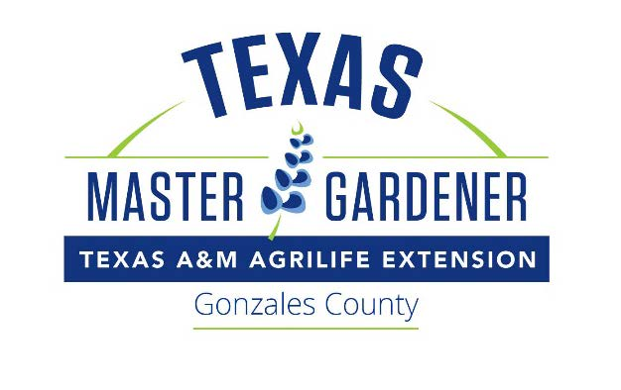
Planned Gonzales Master Gardeners 2023-2024 Class Schedule
8:30am-12:30 pm. At the Plantatarium: A Center for Exploration (PACE), 623 N. Fair Street, in Gonzales.

9-12 Introduction and Tour- Gonzales Master Gardeners Gail Johnson
Chapter 1 - Introduction
9-26 Plant Growth and Development- Jacob Carter and Gail Johnson
Chapter 3 - Plant Growth & Development
10-10 Plant Propagation- Fran Saliger
Chapter 4 – Plant Propagation
10-24 Plants and the Underground Economy - Gail Johnson
Chapter 5 & 6 - Soils, Water and Plant Nutrients
11-7 Field Trip to the San Antonio Botanical Garden Guided Tour
11-21 Starting Seeds- Sandy Llewellyn
Greenhouses – Fran Saliger
12-5 Vegetable Gardening – Bill Nodine
Chapter 10 – Vegetable and Herb Gardening
12-19 Ornamentals and Herbs – Dee Senglemann
Chapter 8 -Ornamental Plants

12-20 Christmas Break

1-9 How to Plant a Tree and Tree Diseases -Carolynn Parratt
1-23 Rainwater Harvesting & Water Conservation- Marcia Lambert
Chapter 7 – Water
2-6 Home Fruit Production Gail Johnson
Chapter 11 – Home Fruit & Nut Production
2-20 Entomology and Integrated Pest Management- Carolynn Parratt
Chapter 13 & 15 – IPM & Insects
3-5 Compost – Gail Johnson
Containers – Shirley Frazier
3-12 Plant Pathology – Carolynn Parratt
Chapter 14 – Plant Diseases
3-26 Landscape Concepts and Design and Earthkind Landscaping– Gail Johnson
Chapter 2 & 12 – Landscape Horticulture & Design
4-9 Turf Grass – Dennis Hale
Chapter 9 - Lawn Care
4-23 Field Trip to Lady Bird Johnson Wildflower Center-Austin- Tour and Native Plants in Landscape Design—Guided Tour
5-7 Field Trip to Luling Foundation, Agricultural Demonstration Farm –
Graduation

